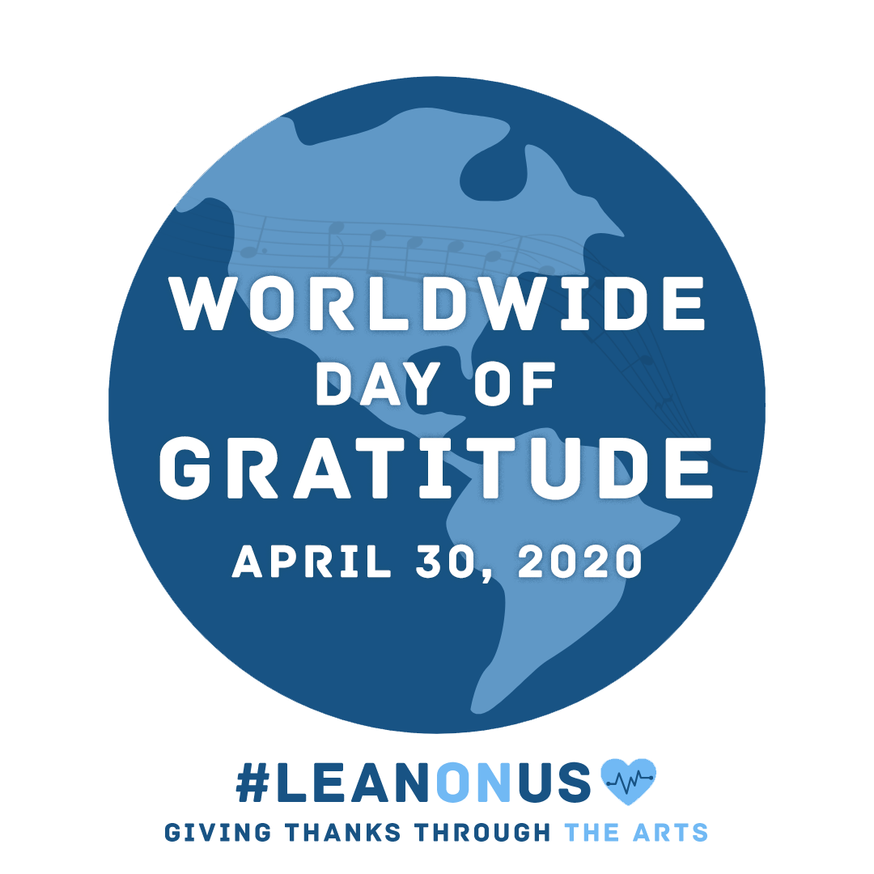

Student Organization Launches ‘Worldwide Day
of Gratitude’ to Honor COVID-19 Heroes

WARREN, New Jersey (April 14, 2020) – First responders and healthcare workers on the front lines of the COVID-19 pandemic will be honored on April 30 as part of “Worldwide Day of Gratitude,” a global coming together through the arts organized by the student-run organization, YOUnison.

Music has long served as a unifying force during challenging times. For Worldwide Day of Gratitude, teachers and students of all ages, as well as the general public, are invited to learn and share the iconic Bill Withers song, “Lean on Me,” which has emerged as a rallying cry for the COVID-19 pandemic.

Starting April 14, sheet music authorized by Hal Leonard Corporation, as well as sample lesson plans and thought starters for participation are available at https://www.younison.org/leanonus.
Participants are encouraged to download the materials, then record and share their unique versions on YouTube and post on social media channels using the hashtags #LeanOnUs and #DayOfGratitude.

“The effort put forth by the first responders and healthcare workers has been incredibly inspiring to so many around the world,” said Andrew E. Morrison, co-founder of YOUnison, a student-centered community empowering YOU to achieve musical excellence based around self-directed learning, creativity and collaboration. “To show our gratitude, teachers, students, and people of all ages can use the power of music and the arts to unite to honor these amazing heroes.”

The Worldwide Day of Gratitude has attracted the attention and collaboration from the leading organizations in music and education, including Arts Ed NJ, Australian Society of Music Education, Berklee Student Government Association, CMA Foundation, Collaborative for Academic, Social, and Emotional Learning (CASEL), Conn-Selmer, CREO (Norway), D’Addario Foundation, Dansr, Drum Corps International, Grammy Museum, Grammy Music Education Coalition, Hal Leonard Corporation, International Federation of Musicians, International Society for Music Education, John Lennon Educational Tour Bus, Kappa Kappa Psi, Little Kids Rock, Music Education Council (United Kingdom), Music First, Music for All, Music Service Learning, Mr. Holland’s Opus Foundation, NAMM Foundation, National Association for Music Education, Noteflight, Phi Mu Alpha Sinfonia, Rock and Roll Forever Foundation, Rock and Roll Hall of Fame, Save The Music Foundation, School Culture and Climate Initiative, SEL4NJ, Social-Emotional and Character Development Lab, Spanish Society for Music Education, SpreadMusicNow, System Blue, Teach Rock, The Lewis Prize, USBands, WGI, Yamaha and YOUnison.

To access sheet music and sample lessons, and to learn more about YOUnison, please visit www.younison.org/leanonus

# # #

About YOUnison
A student-centered community empowering YOU to achieve musical excellence based around self-directed learning, creativity, and collaboration. YOUnison’s mission is to redefine lifelong individual development through music, leadership and social-emotional learning.

Learn more at www.younison.org or contact the team at info@younison.org.

Media Contact
Natalie Morrison - PR Consultant
natmorri@optonline.net

